**A PROJECT REPORT**

**ON**

**“ENTERPRISE WEB APPLICATION FOR WHOLESALE MEDICAL"**

**SUBMITTED TO**

**SHIVAJI UNIVERSITY, KOLHAPUR**

**IN THE PARTIAL FULFILLMENT OF REQUIREMENT FOR THE AWARD OF DEGREE**

**BACHELOR OF TECHNOLOGY IN INFORMATION TECHNOLOGY**

**SUBMITTED BY**

**Mr Adwait Uday Bilaskar 17UEL12010IT**

**Mr Shubham Mahesh Bahekar 17UEL12006IT**

**Mr Sourabh Chandrakant Dhaware 18UIT72003XX**

**Mr Vikas Shivaji Ghol 18UIT72005XX**

**Mr Amit Babaso Shelke 18UIT72014XX**

**Mr Archit Atul Mane 18UIT72008XX**

**UNDER THE GUIDANCE OF**

Prof. V.V.Kheradkar

**DEPARTMENT OF INFORMATION TECHNOLOGY**

**D.K.T.E. SOCIETY’S TEXTILE AND ENGINEERING INSTITUTE, ICHALKARANJI**

(An Autonomous Institute, Affiliated to Shivaji University, Kolhapur)

Accredited with 'A+' Grade by NAAC, An ISO 9001: 2015 Certified

YEAR 2020-21

**D.K.T.E. SOCIETY’S**

**TEXTILE AND ENGINEERING INSTITUTE, ICHALKARANJI.** (An Autonomous Institute, Affiliated to Shivaji University, Kolhapur)

Accredited with 'A+' Grade by NAAC, An ISO 9001: 2015 Certified

**DEPARTMENT OF INFORMATION TECHNOLOGY**



**CERTIFICATE**

**This is to certify that, project work entitled**

**" ENTERPRISE WEB APPLICATION FOR WHOLESALE MEDICAL"**

**is a bonafide record of project work carried out by**

**Mr Adwait Uday Bilaskar 17UEL12010IT**

**Mr Shubham Mahesh Bahekar 17UEL12006IT**

**Mr Sourabh Chandrakant Dhaware 18UIT72003XX**

**Mr Vikas Shivaji Ghol 18UIT72005XX**

**Mr Amit Babaso Shelke 18UIT72014XX**

**Mr Archit Atul Mane 18UIT72008XX**

**In the partial fulfillment of award of degree, Bachelor of Technology in Information Technology prescribed by Shivaji University, Kolhapur for the academic year 2020-21**

**Prof.V.V.Kheradkar**

**PROJECT GUIDE**

**Prof. ( Dr.) D.V.KODAVADE. Prof.(Dr.)P.V.KADOLE**

**(H.O.D. C.S.E.). (DIRECTOR)**

**EXAMINER**

**DECLARATION**

**We hereby declare that, the project work report entitled “TEXT BASED EMOTION RECOGNITION” which is being submitted to D.K.T.E. Society’s Textile and Engineering Institute Ichalkaranji, affiliated to Shivaji University,Kolhapur is in partial fulfillment of degree B.TECH.(IT). It is a bonafide report of the work carried out by us. The material contained in this report has not been submitted to any university or institution for the award of any degree. Further, we declare that we have not violated any of the provisions under the Copyright and Piracy / Cyber / IPR Act amended from time to time.**

**PRN Name Signature**

**17UEL12010IT Adwait Uday Bilaskar**

**17UEL12006IT Shubham Mahesh Bahekar**

**18UIT72003XX Sourabh Chandrakanat Dhaware**

**18UIT72005X. Vikas Shivaji Ghol**

**18UIT72014XX Amit Babaso Shelke**

**18UIT72008XX Archit Atul Mane**

**ACKNOWLEDGEMENT**

With great pleasure, we wish to express our deep sense of gratitude to Mr V. V. Kheradkar for his valuable guidance, support and encouragement in the completion of this project report.

Also, we would like to take the opportunity to thank our head of department Dr.D. V. Kodavade for his co-operation in preparing this project report.

We feel gratified to record our cordial thanks to other staff members of the Computer Science and Engineering Department for their support, help and assistance which they extended as and when required.

Thank you,

**17UEL12010IT Adwait Uday Bilaskar**

**17UEL12006IT Shubham Mahesh Bahekar**

**18UIT72003XX Sourabh Chandrakanat Dhaware**

**18UIT72005X. Vikas Shivaji Ghol**

**18UIT72014XX Amit Babaso Shelke**

**18UIT72008XX Archit Atul Mane**

**INDEX**

1. **Title 7**
2. **Abstract 7**
3. **Introduction 7**
4. **Background study and literature review 8**
5. **Proposed system 10**

5.1 Problem definition 10

5.2 Problem statement 10

5.3 Aim and objectives of proposed system 11

5.4 Scope and limitations of proposed system 12

1. **Requirement Analysis 13**

6.1 Functional requirements 13

6.2 Hardware requirements 14

1. **System Design 15**

7.1 Architecture Diagram 15

7.2 Use case Diagram 16

7.3 Database Diagram 17

7.4 Dataflow Diagram 21

DFD 0 – level 21.1

DFD 1 – level 22

7.5 System flow Diagram 24

7.6 Activity Diagram 26

1. **Implementation 27**

8.1 Algorithmic Description of each module 27

8.2 Detailed Description of Modules 29

8.3 Set up steps of implementation 30

1. **Software Testing 31**

9.1 Unit test cases 31

9.2 Integration test case 33

9.3 System test case 35

1. **Output screen 37**
2. **Performance Analysis 48**
3. **Applications 50**
4. **Conclusion 51**
5. **Installation guide and user manual 51**
6. **Plagiarism report 55**
7. **References 56**

**Attachments :**

* **Scanned copy of sponsorship letter. 57**
* **Scanned copy of completion letter. 58**

**1.** **TITLE**

Enterprise Web application for Wholesale Medical

**2. ABSTRACT**

The existing system has a lot of human interaction. In the current scenario, to take the orders from the retail medical store, one person is allocated to that job. That person goes to every medical store and takes the order. Then this order goes to the wholesale medical store. There they pack the order and send it to the retail medical app. This takes too much time. The current system fails to meet the changing requirements. This app will save the time and improve efficiency. The application provides the placing of order digitally. The retailers will get the order in a short time. So there will be no shortage of medicines on the retailer side. The developing app will try to encounter errors in the current system.

**3.** **INTRODUCTION**

In the current world, online business is growing too fast. Everyone uses the platform of various e-Commerce websites to place an order. This becomes accepted by people because it gives you less time delivery, convenience. It also gives a boost to the e-Commerce business. The world is changing so quickly and the requirements are also changing. The business should go online where they expand the business. This app will try to encounter errors in the current system.

The main aim to develop this app is to enhance the service of wholesale medical. This app reduces the time between the taking of order and delivering an order. The app is designed to take the order and send the order. Typically we are providing one web app for the retail medical store and one web application to the wholesaler. The retailer will place the order from the app according to the need they have. The retailers can search for the product, choose the product and place the order. The wholesaler will get the notification of the order. The wholesaler then packs the products according to the order. Then the products are sent to the retailers with the bill. This will remove the workload of taking orders by physically going there. The wholesaler now sends the order once he receives the notification of the order. This app will help in certain situations where human interaction should be less. It will give retailers them to place the order at their convenience. It will also help wholesaler to expand their business.

**4 . BACKGROUND STUDY AND LITERATURE REVIEW**

The thought to develop the app comes from the irregularities within the existing system. The Existing scenario works with human interaction. A job is allocated to the person to take the orders. However in condition like a natural disaster, pandemic situation or a condition where human interaction should be avoided, this system can fail.

Online shopping is a method of e-commerce where consumers directly buy goods or services from a seller over the Internet using a web browser. However, online shopping has evolved over 35 years, but in India, the rate of acceptance has accelerated in the last decade. There are apps currently in the market like Netmeds, Pharmeasy, etc. that offers medicine directly to the customer. But no system offers medicine to the retail medical store. This is the drawback of the current system. To deal with this drawback, this system is developed. If the retailer faces a shortage of medicines, then a retailer should be able to order the required medicines at any point in time and from anywhere.

**[1] Ashwani Chaturvedi, Amrish Kumar. "Online pharmacy : An E -Strategy for mediation ", April 2011**

Online pharmacy offers a lot of offers. Patients with less mobility and those living far from the medical store can benefit tremendously. Potential customers are attracted towards these online pharmacy sites by the large scale advertisement on TV, Internet, print media. Customers can get prescription drugs without speaking to a pharmacist or Doctor. The patient can treat themselves without going to the Doctor. The government has made the act so that the 'Food and Drug Association' can take the legel action against the none permissible action by online pharmacy companies. 'World Health Organisation' also regulates online pharmacy.

**[2] Mohammad Osman Gani. "The distribution system of pharmaceutical products". July 2013.**

Distribution is one of the most important business activities as it ensures the visibility and availability of the particular product in the market. The Channel of distribution determines the route along which products travel from manufacture to intermediaries to the final user. The organization functions are considered as complete when the organization can deliver the products at the right time and right place. Without intermediaries, no producers can deliver the products. A distribution channel is key for every pharmaceutical company. Every company has its way of distributing products.

**[3] Mishara R, Sathyaseelan B ."Generic Drug Distribution in India and Challenges".**

The major players in the Indian pharmaceutical market are Sun Pharma, Dr Reddy’s, Lupin, Cipla, Aurobindo, Candila. Glenmark, Torrent Pharma, Alkem Lab, Divis Lab, Piramal Enter, Ipca Lab, Glaxo SmithKline, Abbott India, Biocon, Jubilant life. Indian pharmaceutical industry is famous for its export of generic pharma products. Most generic drugs sold in the retail pharmaceutical stores are branded, which come at a premium In 2002 the MCI released guidelines to physicians to prescribe drugs to the patient by their generic names only and to avoid mention of branded names in the prescription. To address some of these challenges, the Government of India and some states in India have launched schemes or programs that aim to provide quality medicines at affordable prices to the masses all over the country through special centres.

e.g. Pradhan Mantri Bhartiya Jan aushadhi pariyojna (PMBJP)

. Initiative by Rajasthan government through the Rajasthan medical services corporation Ltd

**[4] Abhishek Malhotra, Amit saharia. "India’s Pharma Supply Chain: Does the Industry Have What It Takes to Win?" .2016**

India pharma market now stands at $30 billion with highest number of FDA approved sites after US. Facing competition from domestic and multinational players, Indian pharma companies have started to diversify and are taking bold steps to strengthen their portfolios. A key challenge Indian organisation s face is that the business differentiator is shifting from being reverse-engineering experts to having improved operational performance parameters such as service level and cost to deliver. Competition is fierce. Supply chain improvements needs strong interaction with government and industry bodies will be essential. The comprehensive change will require commitment from top management, coupled with a capable execution team that can help sustain the benefits.

**[5] Eric langer, Abhijeet kelkar. "Pharmaceutical Distribution in India". September 2008**

The Indian pharmaceutical industry is continuing its high growth rate at 13% for the last six years. India is a geographically diverse country with extreme climates that make distribution a critical function. Before 1990, pharam companies use different distribution of system in which they create their own depots and warehouses that now replaced by clearing and forwarding agents (CFAs). The retail pharmacy obtains products from the stockist or substockist through whom it finally reaches the consumers (patients). Manufacturers must ensure that their drug reaches customers with uncompromised quality. However, manufacturers are increasingly realizing the importance of an effective distri-bution system, all the way to the end-customer.

**5. PROPOSED SYSTEM**

**5.1 PROBLEM DEFINITION**

The patients suffering from chronic diseases depends on the medicines for the rest of his life, the retailers sometimes due to a shortage of medicines fail to satisfy the interests of the patient, which makes the patient run from one pharmacy to another. This shortage will affect the business. There are a lot of websites that offer medicines directly to the customer. But no system offers medicine to retailers. The retailer creates their account and login into the system and order medicines. The wholesaler creates their account and login into the system and checks orders received by the retailers. According to the orders, they deliver the orders.

**5.2 PROBLEM STATEMENT**

This main aim to develop an online medicine order for retailers with the goal so that it is become very easy to order from a wholesaler. Creating a website that offers medicine only to the retailers. Retailers will see the products at the wholesaler’s side and order the products.

**5.3 AIM AND OBJECTIVES OF PROPOSED SYSTEM**

The main aim is to save time. Retailers can save valuable time. Retailers can select those products which they want to buy. The primary aim of this project is to demonstrate online order with better interactive features that will improve sales. The purpose of the application is to automate and facilitate the whole process of medicine order. This application fixes the limitation and problems of the current system.

The objectives of the proposed system are ---

* Providing web application for both retailer and wholesaler.
* Providing login facility for retailers and wholesalers for authentication.
* Providing retailers to see the product and order the product.
* Let the retailer see the summary of the order.
* Retailers can track the order.
* Retailers will get the confirmation of order notification.

*Service and product advertisement –*

The main purpose of an online business is to promote a company’s products, services or events on the Internet. The retailer can view the products at the wholesaler side and order the product.

*Selling a product or a service online-*

This is the main reason behind the existence of any business website. Selling products and services is the most common objective.

**5.4 SCOPE AND LIMITATIONS OF PROPOSED SYSTEM**

The web application in this project will make a lot of impact on business. It rotates the business cycle fastly. This will be free to use the app. The hectic work for middlemen will be minimised by this app. This system can allow retailers to create their account and order the products from wholesalers. It is a B2B type i.e. Business to Business online shopping. A shopping cart is one of the important facility in the system so that retailers can pick the product for purchase and place in the cart and continue browsing until final selection.

As it is all maintained digitally, the technological cost is huge. A lot of money needs to be invested to build the technical infrastructure. And it should be upgraded based on changing technology. Needs advanced technology platforms for better performance To access the system, the retailer should have a compatible system. If the system crashes, then it affects the business. There will be a delay in the delivery of products if any unavoidable situation arises.

**6. REQUIREMENT ANALYSIS**

**6.1 FUNCTIONAL REQUIREMENTS**

Given below are the functionalities of our proposed system which is an enterprise web application for wholesaler

**Functionality 1:**

Providing login facility for retailers and wholesalers for authentication.  
**input :** Login ID & Password  
**output :** Successfully Login.

**Description :** Retailer and wholesaler will create account and login into the system. So that, only authenticated users will enter the system   
   
**Functionality 2:**

Providing retailers to see & search the product and order the product  
**input :** Product's Name   
**output :** Product found / Not Found

**Description :** After successful login, the system will display the home page. On this page, various options there. The retailer can search for the product they want to buy.

**Functionality 3:**

Let the retailer see the summary of the order.  
**input :** Display of the products ordered which retailer placed  
**output :** Summary of placed order  
**Description :** Retailer can add the products to the cart until the final selection. Once he did, then he can place the order. The retailer can see the summary of the placed order.

**Functionality 4:**

Retailers can track the order.  
**input :** Click on 'track order'.  
**output :** Update on order.

**Description :** Retailer place the order. The wholesaler gets the order from the retailer. The wholesaler can give an update on order. When the retailer clicks on 'track order', the update given by the wholesaler will be displayed.

**Functionality 5:**

Retailers will get the confirmation of order notification.

**input :** Order placed successfully

**output :** Confirmation of order

**Description :** Retailers place the order. The wholesaler gets the order notification. When the wholesaler confirms the order then the retailer gets the confirmation of the order.

**6.2 HARDWARE REQUIREMENTS**

* Personal Computer with standard configuration
* RAM – minimum 4 GB
* Processor – Intel Core i3 or higher.
* Storage – minimum 80 GB

**7 . SYSTEM DESIGN**

**7.1 ARCHITECTURE DIAGRAM**

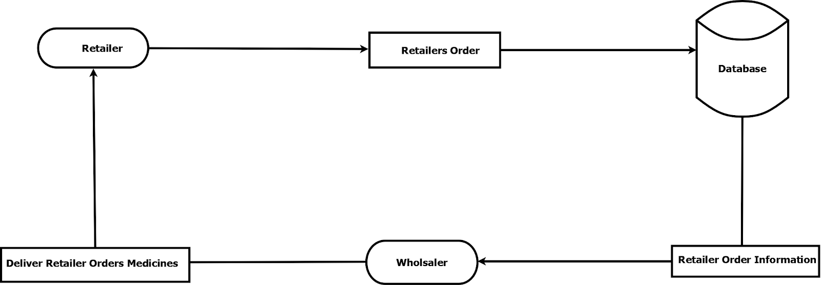

Fig .7.1 Architecture Design

**Description** -

Retailer: First retailer login into the system. After the login retailer search for the medicines. Retailer selects the medicines from the system that retailer needs and order them.

Retailer order: Retailer order contains retailer information like Name.ID, Mobile no, Address etc.

Database: In the database, all the retailer information and its order information is stored like Date, time, Retailer name, products, payment, address, etc. Retailer information is passed to the wholesaler through SMS, which contains order information and retailer information.

Wholesaler: A wholesaler is a person who takes an order from retailer and delivers it. Wholesaler login into the system and checks the order section if he/she finds some order in the order section then they accept that order and deliver it to the retailer and gets payment on cash_on_delivery mode.

**7.2 USE CASE DIAGRAM**

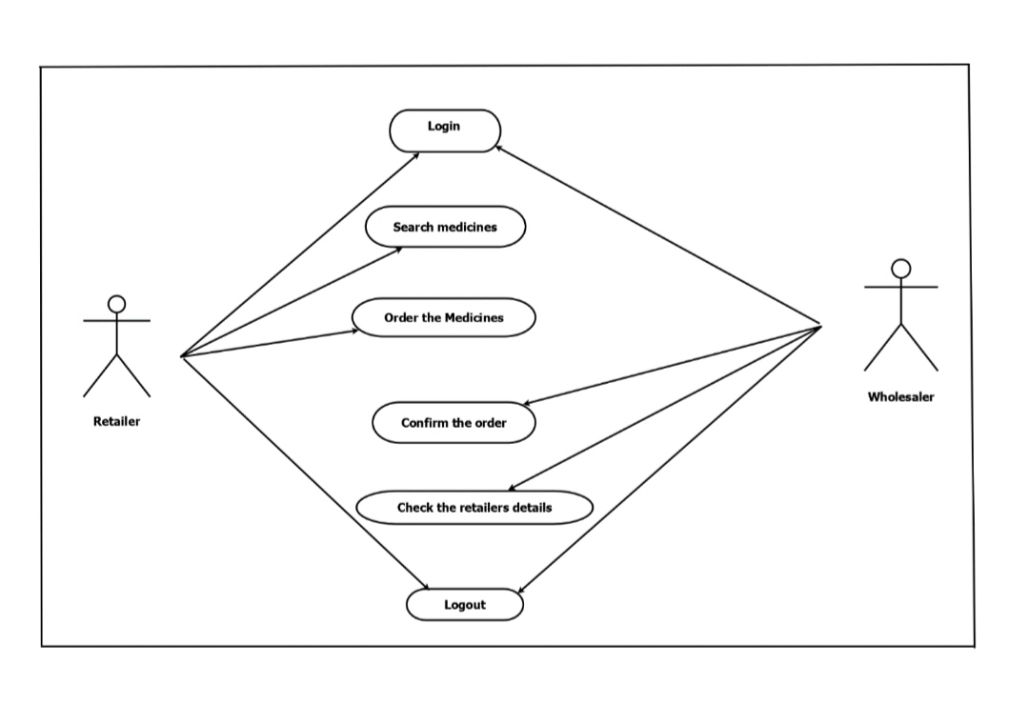

Fig. 7.2 Use Case Diagram

**Description**:

Actor: Wholesaler, Retailer

The retailer can log in to the system, search for medicines, after searching for medicines retailer can order the medicines.

The wholesaler can log in to the system, the wholesaler can confirm the order ordered by the retailer. The wholesaler can check the retailer details. The wholesaler can decide product price.

**7.3 DATABASE DESIGN**

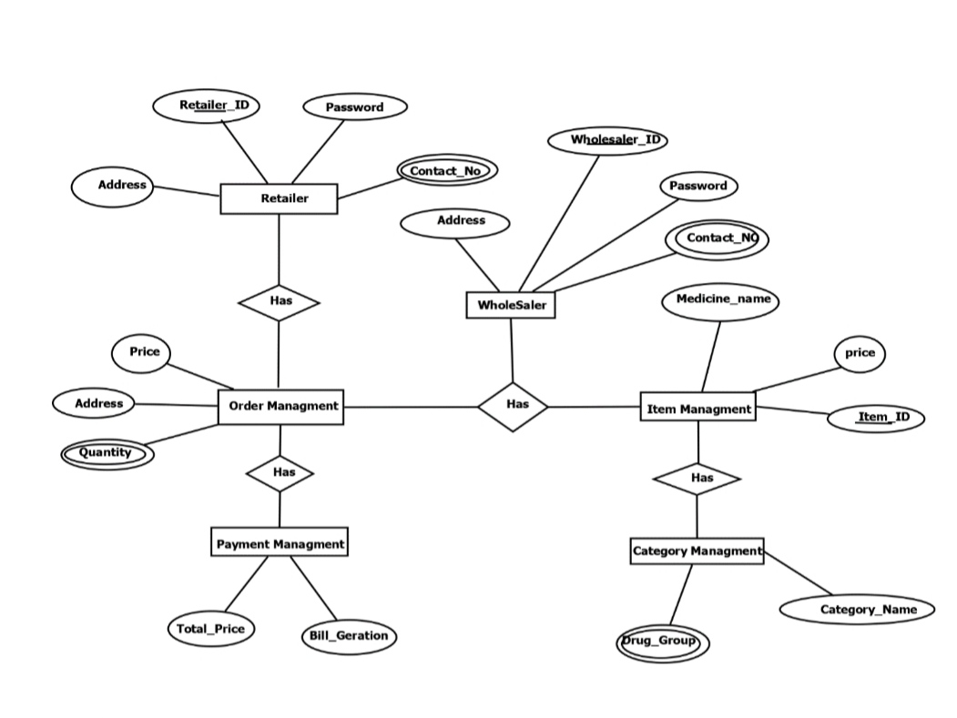

Fig. 7.3 Database Design

**Description:**

Retailer: The retailer is the person who places the order. The retailer has attributes. Retailer id, Password, Address, Mobile no these are the retailer’s attributes. When retailer searches and select medicines and place the order that order request is sent to the order management.

Order management: order management takes order information from the retailer and sends it to the wholesaler. Order management has a price, Address and quantity attributes. Order management sends retailer information to the payment management also.

Wholesaler: A wholesaler is a person who takes an order from a retailer and delivers it. A wholesaler takes order information from order management. The wholesaler has Id, password, address, contact no attributes. The wholesaler also manages the item and category management.

Item management: Item management manages medicines. It contains medicine name, price, id etc.

Category management: It contains drug group and category name.

Payment management: it has the total price and bill of the medicines ordered by the retailer. Payment management is under order management.

**Description –**

**Retailers**

|  |  |
| --- | --- |
| **Column** | **Description** |
| Retailer_id | The primary key |
| Password | Password of retailer id |
| Address | Retailer address |
| Contact No | Contact no of retailer |

**Wholesaler**

|  |  |
| --- | --- |
| **Column** | **Description** |
| Wholesaler_id | The primary key |
| Password | Password of wholesaler id |
| Address | Address of wholesaler |
| Contact no | Contact no of wholesaler |

**Order management:**

|  |  |
| --- | --- |
| **Column** | **Description** |
| Price | Total Price of the medicines |
| Address | Delivery address |
| Quantity | Quantity of the medicines |

**Item management**

|  |  |
| --- | --- |
| **Column** | **Description** |
| Medicine name | Name of the medicine like crocin |
| Price | Individual price of medicine |
| Item id | Medicine id |

**Payment management:**

|  |  |
| --- | --- |
| **Column** | **Description** |
| Total price | Overall price of the ordered medicines |
| Bill generation | Medicines bill |

**Category management:**

|  |  |
| --- | --- |
| **Column** | **Description** |
| Category name | Medicine category |
| Drug sends | Drug group of medicine |

**7.4 DATAFLOW DIAGRAM**

* **DFD 0 - LEVEL -**

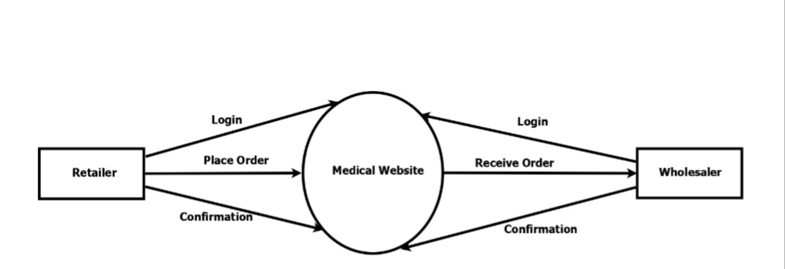

Fig. 7.4 (a) DFD 0 - level

*Description*:

Retailer: The retailer can log in to the system. Retailer place the order. After placing an order retailer gets confirmation from the system.

Wholesaler: Wholesaler can log in to the system. He can check the order. He can confirm the order.

Medical website: The website act as a mediator between wholesaler and retailer. It accepts order information from the retailer and sends it to the wholesaler. Once the order confirmation system sends the confirmation message to the retailer.

* **DFD 1-LEVEL**

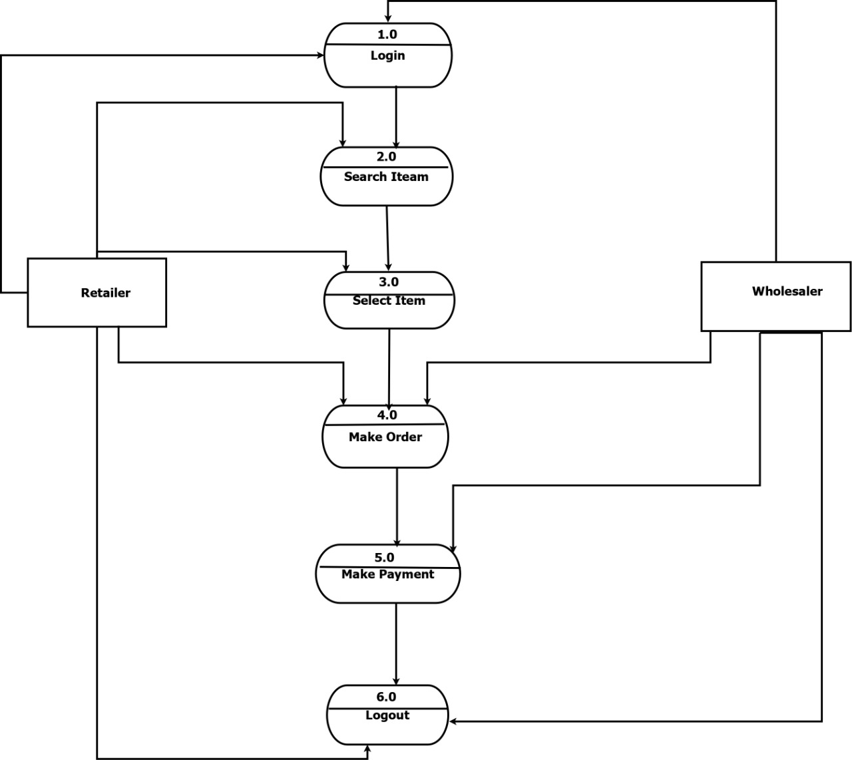

Fig. 7.4 (b) DFD 1- level

*Description*:

Retailer: The retailer sends login information to the login module for information validation. The login module takes request for new user and stores user information into the database. Once login retailer can search the medicines and select required medicines. After selecting medicine retailer can place an order and after delivery, the retailer can pay the billing amount.

Wholesaler: Wholesaler sends login information to the login module for information validation. After login wholesaler can check its received order section. If an order is present their then the wholesaler accepts it and makes a delivery. After delivery wholesaler can get payment on COD mode*.*

**7.5 SYSTEM FLOW DIAGRAM**

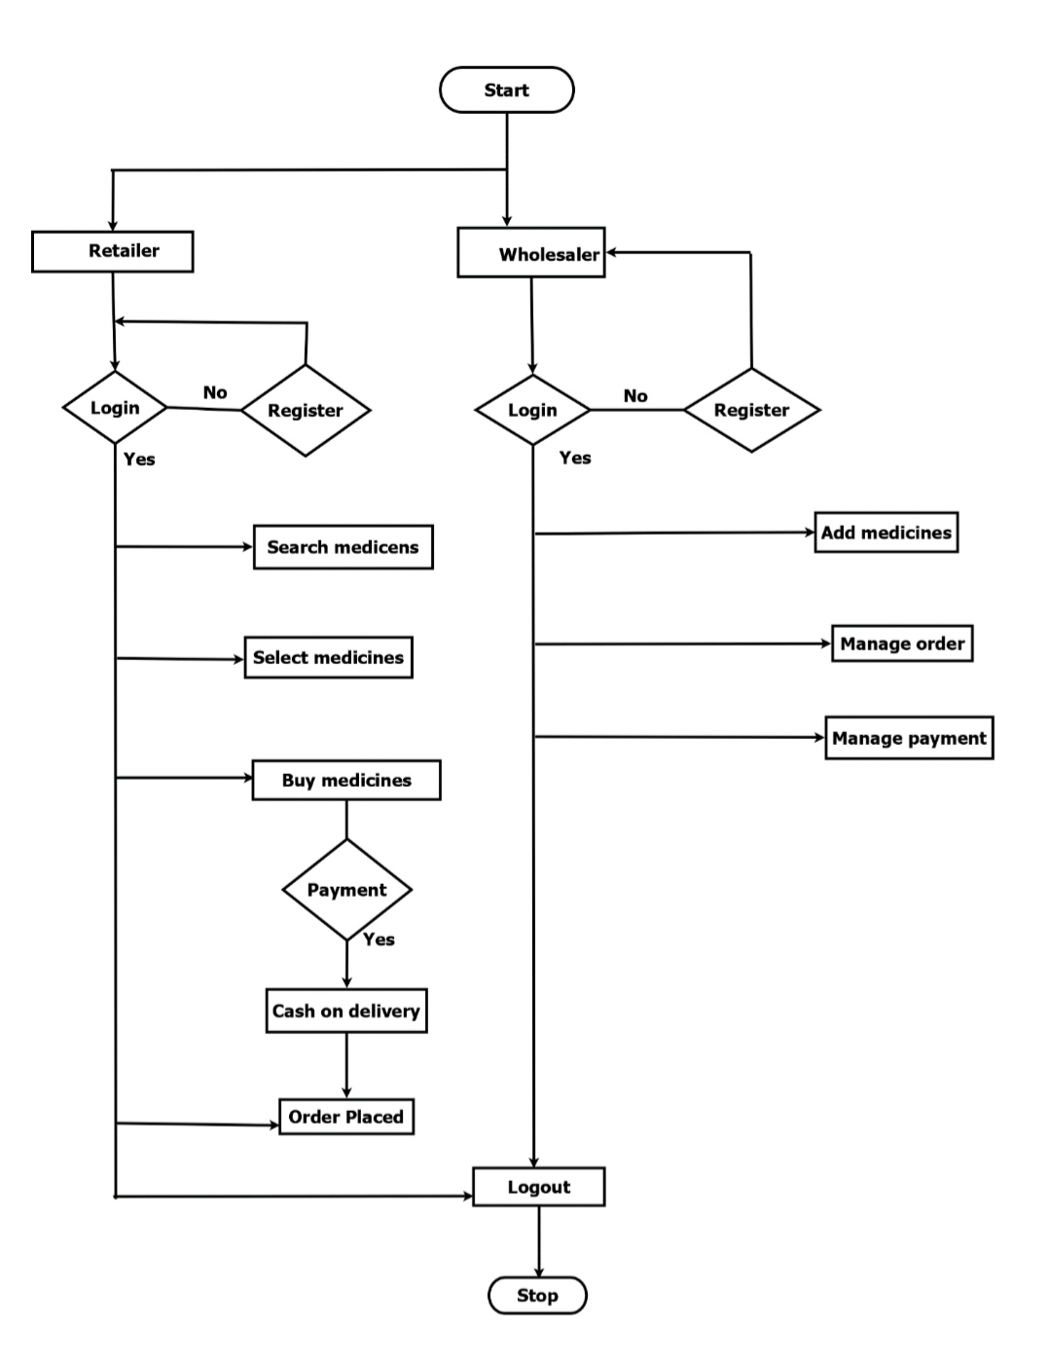

Fig. 7.5 System Flow Diagram

**Description:**

Retailer : First retailer login in into the system if he/she has registered already then he/she can log in if not then he/she first register into the system and then login. After successful login retailer can search the medicines, select the medicines and buy the medicines. After buying retailer have to select payment mode cash-on-delivery. The retailer places the order and can log out from the system.

Wholesaler : First wholesaler login in into the system if he/she has registered already then he/she can log in if not then he/she first register into the system and then login. After successful login wholesaler can add the medicines, manages the order and manage the payment. After that wholesaler can logout.

**7.6 ACTIVITY DIAGRAM**

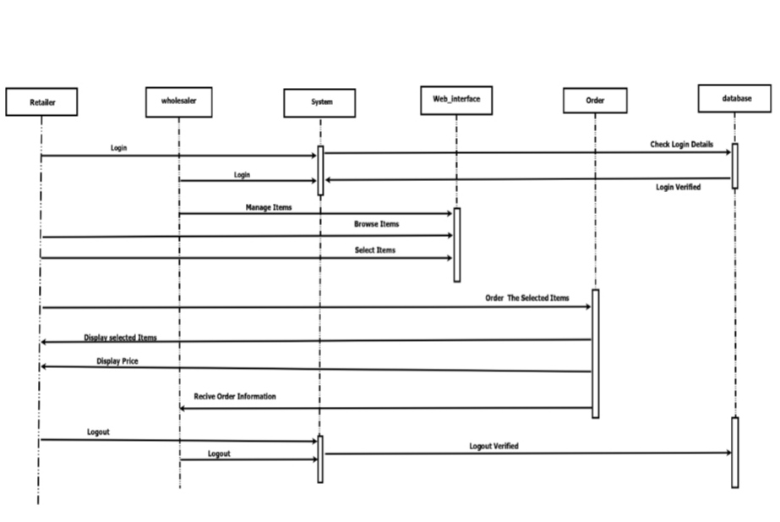

Fig.7.6 Activity Diagram

**Description**  : Retailer and wholesaler send login information to the system. The system validates information and logs wholesaler and retailer into the system. Once login retailer can browse the item and select the item. The wholesaler can manage the item. The retailer can order the selected medicines in that selected items and the price of the medicines are displayed to the retailer. After placing an order wholesaler receive the order information of the retailer. The wholesaler confirms the order and delivers medicines to the retailer.

**8. IMPLEMENTATION**

**8.1 ALGORITHMIC DESCRIPTION OF EACH MODULE**

* **Module - Registration module**

get user Id (Name, password, mail, etc.)

If (id data validated in front)

Then send for backend validation

Else

Go back to 1

If (backend validation OK)

Then user creation OK

Else

opération failure

* When retailer or wholesaler fill in the correct information then the system will check the data and register the user.
* If any of the information is missing then an error message will display.

* **Module 2 - login module**

get (mail or username) and password

If (both match with the ones in the database)

Then allow login.

Else

Login failure.

* This module will use the user id and password to proceed further.
* The output of this module is successful login.
* **Module 3 - Dashboard**

This module will display various options of the system after the successful login.

The output of this module will display the various options of the system.

* **Module 4 - Adding product to cart**

A product cart has n items and the n items are supplied by the supplier.

Retailers can manage all of the things they want to buy beforehand; make specific changes in quantity, sizes, colours; carry out checkout process,

When the retailer clicks on the add to cart option, then the product will add to the cart.

It will display the products placed in the cart.

The output of this module will list all products in the cart.

* **Module 5 - Order summary**

This module will give a brief description of the final order placed.

This module will display the final order received by the wholesaler.

The output of this module is the final order by the retailer.

**8.2 DETAILED DESCRIPTION OF EACH MODULE**

* **Registration Module**

**Module name -** Registration module

**Input -** Name, Contact No. , Email ID

**Output -** Account successfully created.

**Description -** Both retailer and wholesaler will create their account by filling in all the required information to proceed further.

* **Login Module**

**Module name -** Login module

**Input -** Email ID, Password

**Output -** Successful Login. Home page will be displayed.

**Description -** Both Retailer And Wholesaler Will Login Their Account After Creating One; they will log in through unique ID & Password

* **Dashboard Module**

**Module name -** Dashboard module

**Input -** Succesful Login

**Output. - A home** page containing various options will be displayed.

**Description -** After login into the system, various options of the system will display to the user.

* **Adding Products To Cart From Retailer's End**

**Module name -** Adding Products To Cart From Retailer's End.

**Input -** Click on 'Add to cart.

**Output. -** Products added to the cart successfully.

**Description -** After The Successful Login, The Retailer Will First Search The Products According To Their Requirement And Then Will Add The Products In The Cart.

* **Order Summary**

**Module name -** Order summary.

**Input -** Add products to the cart and click on 'Order summary'.

**Output. -**  Order Summary will be displayed.

**Description -** The Retailer Will Be Able To Check The Order Summary.

**8.3 SET UP STEPS FOR IMPLEMENTATION**

* Install sublime text editor.
* Instal Xamp server.
* Configure Xampp server.
* Use database phpMyadmin for creation of database.
* Run the project .

**9. SOFTWARE TESTING**

**9.1 UNIT TEST CASE GENERATION AND ITS TESTING REPORTS**

Test cases for each unit testing with the following tables:

**Login Page -**

|  |  |  |  |  |  |
| --- | --- | --- | --- | --- | --- |
| **Test Case No.** | **Test Case** | **Input** | **Expected O/P** | **Actual O/P** | **Status** |
| 1 | Retailer/ Wholesaler Login with Correct ID & Password | Correct ID & Password | Successful Login | Successful Login | Pass |
| 2 | Retailer/ Wholesaler Login with Incorrect ID & Password | Incorrect ID & Password | Successful Login | Error | Fail |
| 3 | Retailer/ Wholesaler Login with Correct ID & Incorrect Password | Correct ID & Incorrect | Successful Login | Error | Fail |
| 4 | Retailer/ Wholesaler Login with Incorrect ID & Correct Password | Incorrect ID & Correct Password | Successful Login | Error | Fail |

**Search & Add Product -**

|  |  |  |  |  |  |
| --- | --- | --- | --- | --- | --- |
| **Test Case No.** | **Test Case** | **Input** | **Expected O/P** | **Actual O/P** | **Status** |
| 1 | Search & Add Product | Search & Add Product | Successful  Transaction | Product Found & Order Placed | Pass |
| 2 | Search & Add Unavailable Product | Search & Add Product | Successful  Transaction | Product Not Found | **Fail** |

**Order Notification -**

|  |  |  |  |  |  |
| --- | --- | --- | --- | --- | --- |
| **Test Case No.** | **Test Case** | **Input** | **Expected O/P** | **Actual O/P** | **Status** |
| 1 | Order Notification | Order Placed | Notification Received | Notification Received | Pass |
| 2 | Order Notification | Order Placed | Notification Received | Notification Not Received | Fail |

**9.2 INTEGRATION TEST CASE GENERATION AND ITS TESTING REPORTS**

Test cases for each integration testing with the following tables :

**Module 1 - Registration module**

|  |  |  |  |  |  |
| --- | --- | --- | --- | --- | --- |
| **Test Case No.** | **Test Case** | **Input** | **Expected O/P** | **Actual O/P** | **Status** |
| 1 | Retailer/Wholesaler register into the system | Required information | Successfully Register. | Successfully Register | Pass |
| 2 | Retailer/Wholesaler register unable to register | Incomplete information | Successful register | Error | Fail |

**Module 2 - Login module**

|  |  |  |  |  |  |
| --- | --- | --- | --- | --- | --- |
| **Test Case No.** | **Test Case** | **Input** | **Expected O/P** | **Actual O/P** | **Status** |
| 1 | Retailer/wholesaler login with correct id and password | Correct ID and password | Successfully login | Successfully login | Pass |
| 2 | Retailer and wholesaler login with incorrect id and password | Incorrect id and password | Successfully login | Errors | Fail |

**Module 3 - Dashboard module**

|  |  |  |  |  |  |
| --- | --- | --- | --- | --- | --- |
| **Test case No.** | **Test case** | **Input** | **Expected O/P** | **Actual O/P** | **Status** |
| 1 | To display the homepage of the system that has various options. | Site address | Hompage display on the screen | Homepage displayed | Pass |

**Module 4 - Adding products to the cart**.

|  |  |  |  |  |  |
| --- | --- | --- | --- | --- | --- |
| **Test case No** | **Test case** | **Input** | **Expected O/P** | **Actual O/P** | **Status** |
| 1 | To add products to the cart | Mouse rollover and click | Product added to the cart | Product successfully added to the cart | Pass |

**Module 5 - Order summary**

|  |  |  |  |  |  |
| --- | --- | --- | --- | --- | --- |
| **Test case no.** | **Test case** | **Input** | **Expected O/P** | **Actual O/P** | **Status** |
| 1 | To check order summary | Mouse rollover and click | Display order summary | Order summary displayed | Pass |

**9.3 SYSTEM TEST CASE GENERATION AND ITS TESTING REPORTS**

Test case for each system testing with following tables :

**Login Facility for Retailer and Wholesaler**

|  |  |  |  |  |  |
| --- | --- | --- | --- | --- | --- |
| **Test case no.** | **Test Case** | **Input** | **Expected O/P** | **Actual O/P** | **Status** |
| 1 | Retailer/ Wholesaler Login with Correct ID & Password | Correct ID & Password | Successful Login | Successful Login | Pass |
| 2 | Retailer/ Wholesaler Login with Incorrect ID & Password | Incorrect ID & Password | Successful Login | Error | Fail |
| 3 | Retailer/ Wholesaler Login with Correct ID &Incorrect Password | Correct ID & Incorrect  Password | Successful Login | Error | Fail |
| 4 | Retailer/ Wholesaler Login with Incorrect ID &Correct Password | Incorrect ID & Correct Password | Successful Login | Error | Fail |

**See the product and order the product**

|  |  |  |  |  |  |
| --- | --- | --- | --- | --- | --- |
| **Test case no.** | **Test Case** | **Input** | **Expected O/P** | **Actual O/P** | **Status** |
| 1 | See the product and order the product. | Mouse rollover and click | Order placed successfully | Order place successfully. | Pass |

**Order Notification**

|  |  |  |  |  |  |
| --- | --- | --- | --- | --- | --- |
| **Test case no.** | **Test Case** | **Input** | **Expected O/P** | **Actual O/P** | **Status** |
| 1 | check order summary | Mouse rollover and click | Display order summary successfully | Order summary displayed successfully. | Pass |

**Track order**

|  |  |  |  |  |  |
| --- | --- | --- | --- | --- | --- |
| **Test case no.** | **Test Case** | **Input** | **Expected O/P** | **Actual O/P** | **Status** |
| **1** | Track the order | Mouse rollover and click on 'track order' | Update on order . | Update on order | Pass |

**Summary of order**

|  |  |  |  |  |  |
| --- | --- | --- | --- | --- | --- |
| **Test case no.** | **Test Case** | **Input** | **Expected O/P** | **Actual O/P** | **Status** |
| 1 | To check order summary | Mouse rollover and click | Display order summary | Order summary displayed | Pass |

**10. OUTPUT SCREEN**

1. **Retailer login and registration page**

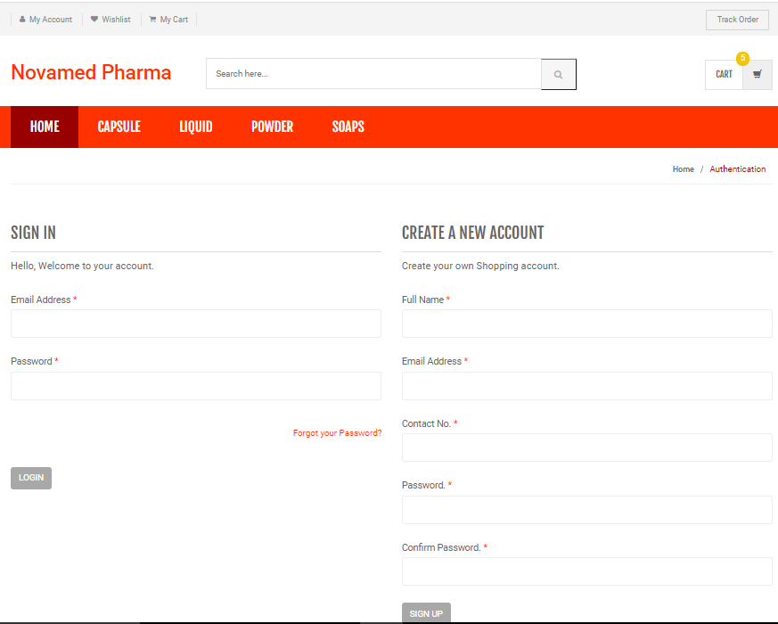

Snapshot - Retailer login and registration page

**Description** - Retailers will log in to the system. If a retailer has no account then he will register first then log in.

**2) Retailer home page**

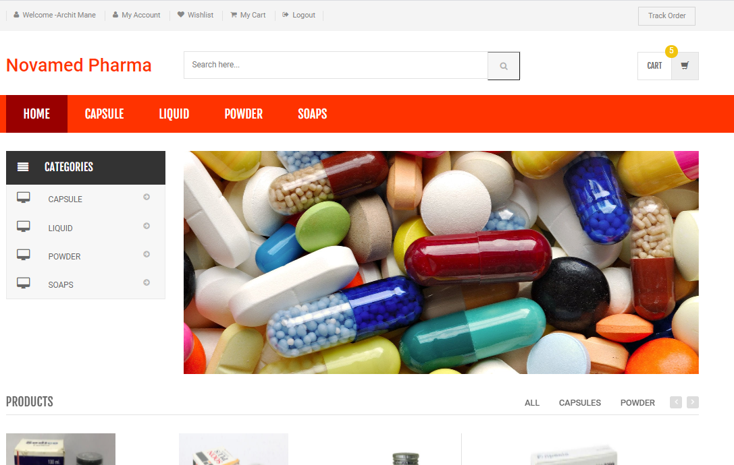

Snapshot - Retailer home page

**Description -** After login retailer will see this screen. Here various options are to present. User can navigate through this.

**3) Retailer account page**

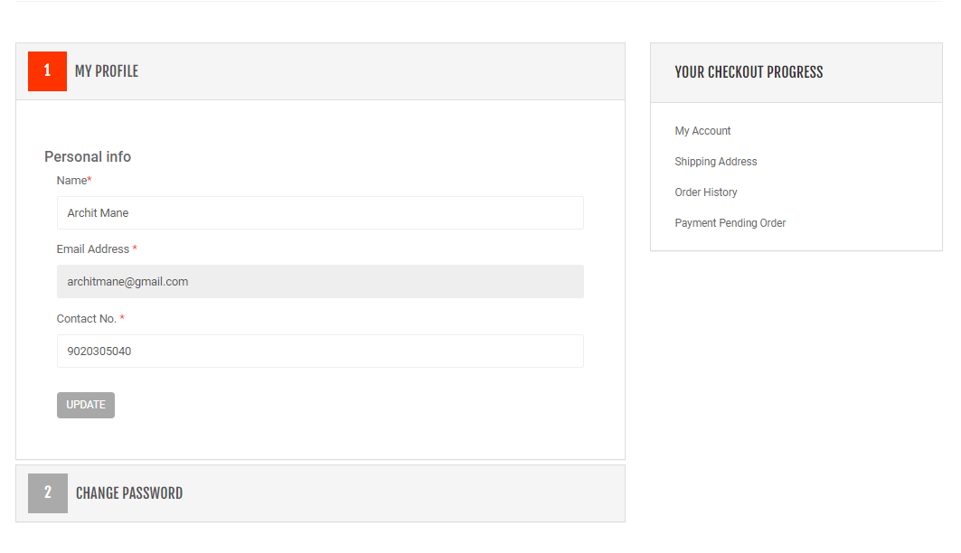

Snapshot - Retailer account page

**Description -**  Retailer can fill /edit his information by navigating through the 'My Profile' option.

4) **Retailer wishlist page -**

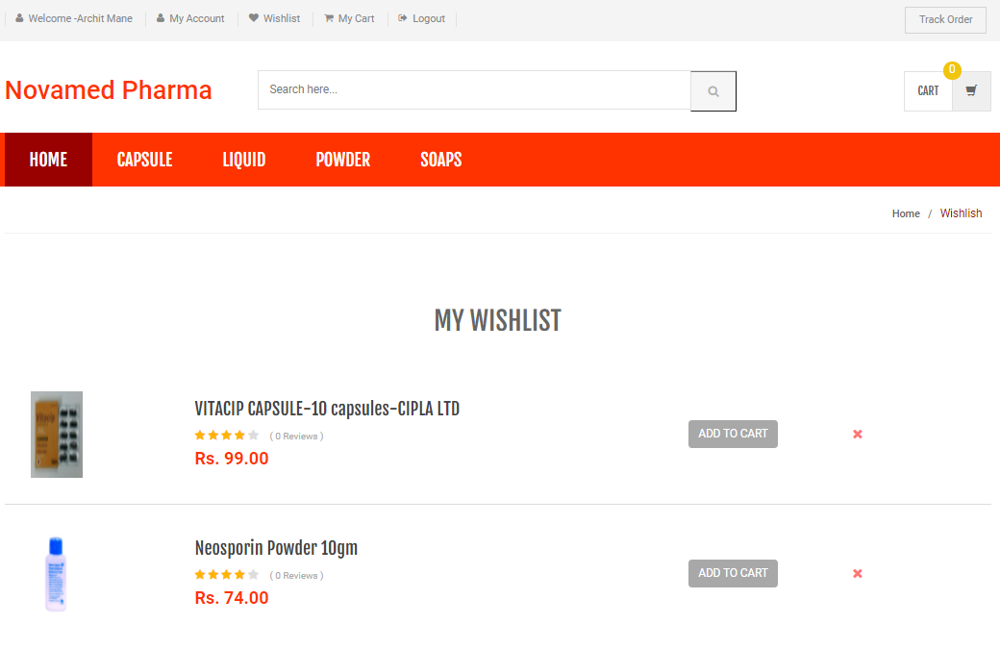

Snapshot - Retailer wishlist page

**Description -** The wishlist of retailers will display here. User can navigate through the My wishlist option to see his wishlist.

5) **Add to cart page -**

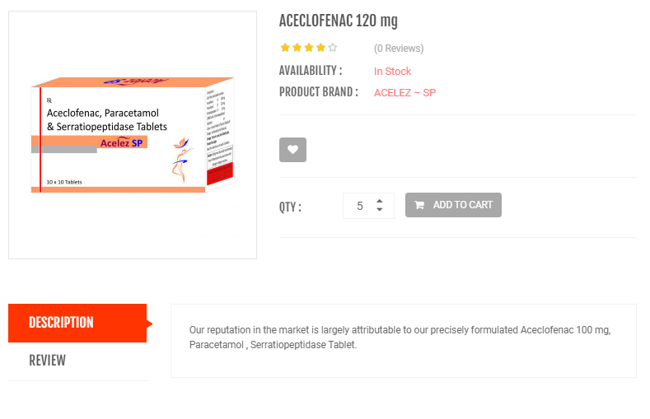

Snapshot - Add to cart page

**Description** - The retailer will add the product to the cart to place the order by clicking on add to cart option.

6) **My cart -**

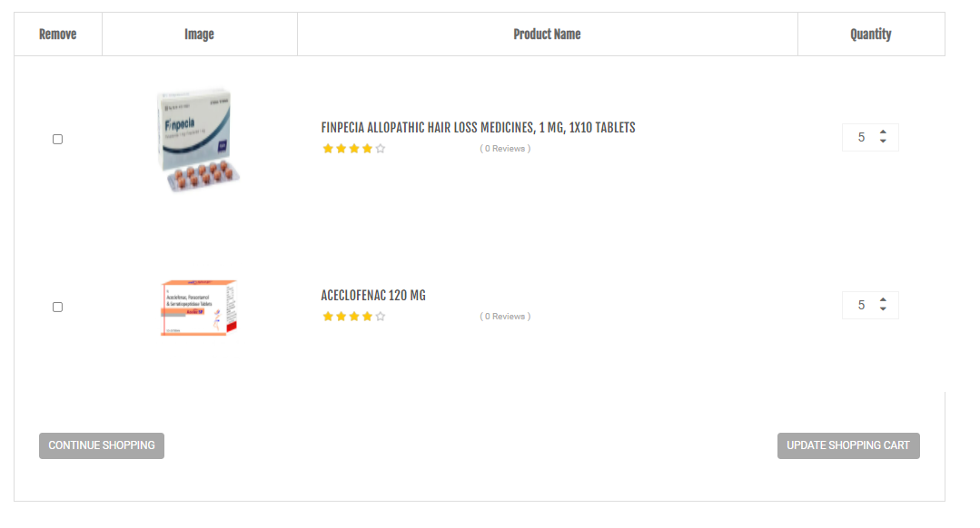

Snapshot - My cart

**Description -** The retailer will see his cart in which the to be purchased will appear. A retailer can increase or decrease the quantity of the products and also can add or delete the

7) **Shipping address page -**

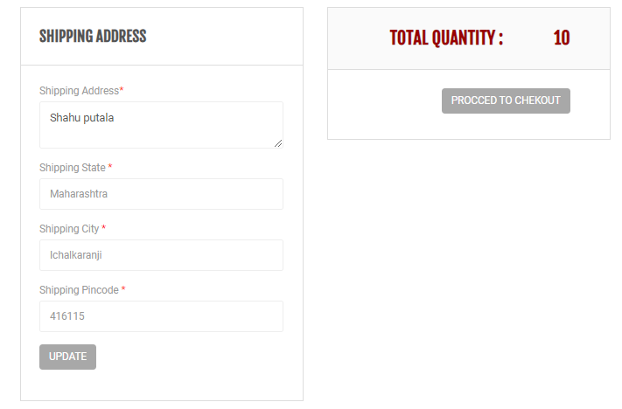

Snapshot - shipping address page.

**Description -**  Retailer can fill the shipping address of the delivery of products.

8) **Wholesaler login page -**

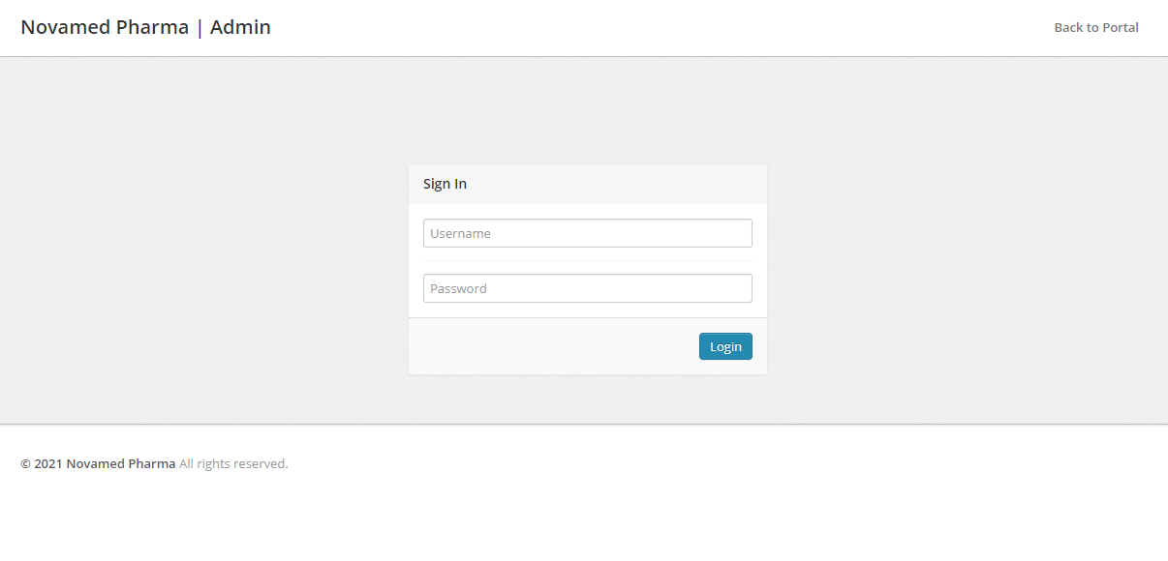

Snapshot - Wholesaler login page

**Description -**  Wholesaler will log in to the system by user name and password to proceed further.

9) **Wholesaler add new product -**

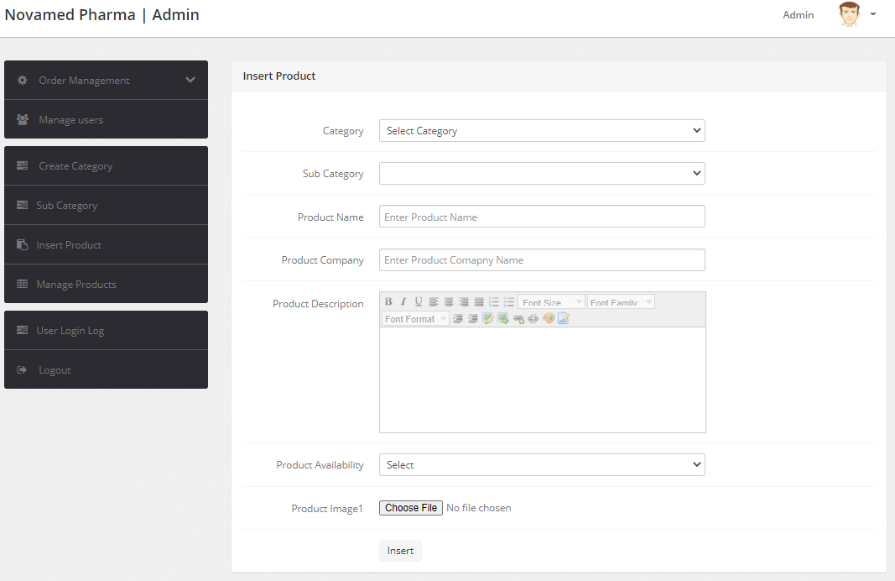

Snapshot - Wholesaler add new product

**Description -** Wholesaler will add new products to the system. The required fields like category, product name, product description, product image, etc field are filled by the wholesaler.

10) **Wholesaler add a new category -**

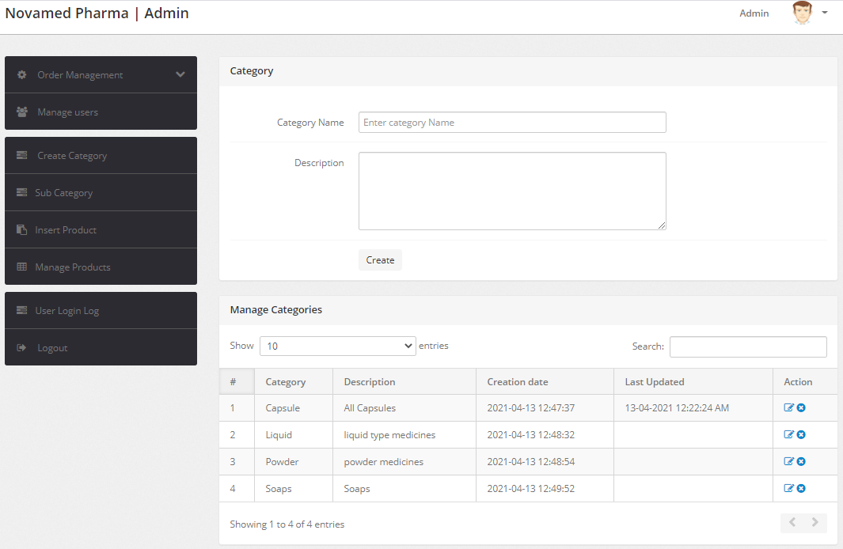

Snapshot - Wholesaler add a new category of products

**Description -**  Wholesaler will add a new category of products by filling all the required fields.

11) **Wholesaler manage the product.**

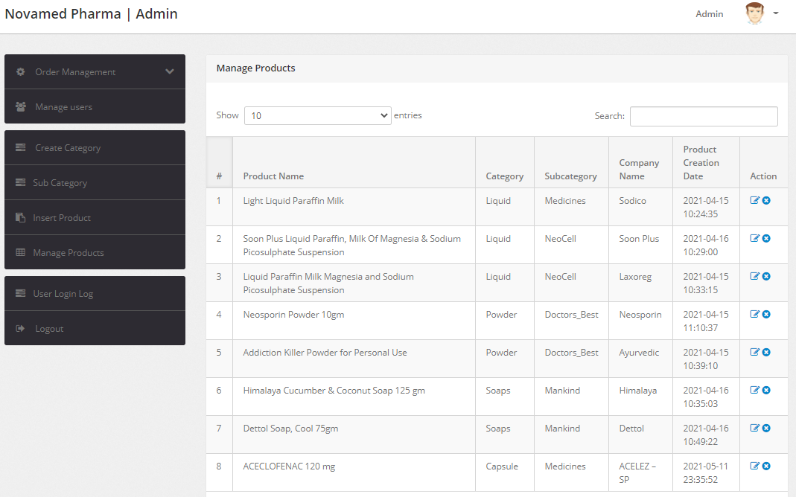

Snapshot - Wholesaler manages the products.

**Description -**  Wholesaler have all the control of the system. He can manage all the products.

**11. PERFORMANCE ANALYSIS**

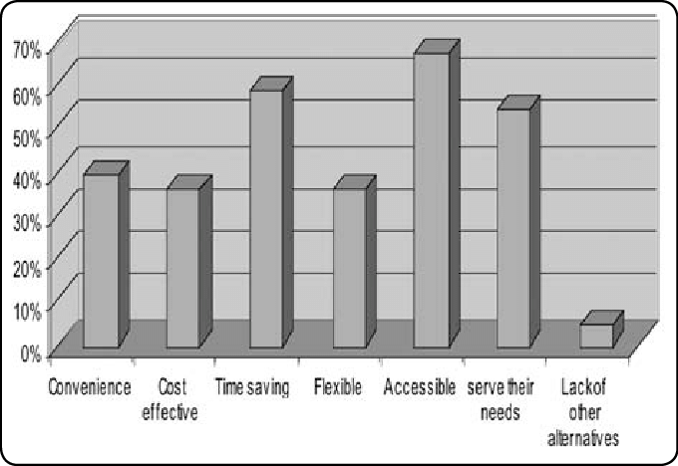

**Description -**

* Convenience : The retailer can order the products conveniently. Wholesaler can conveniently see the order and deliver the order. Retailer can place the order from anywhere.
* Cost-effective : Just need to install the web browser as it is a web application. Management cost in the current system gets eliminated in the proposed system.
* Time-saving : The delay in the current system is encountered in the proposed system. Retaileplacesce the order through the internet, so wholesaler can deliver the products easily without much time-consuming. Time will be saved
* Flexible : Can open from any web browser, easy order placing, fast delivery, can see the product details. Same type of system can develop for other products.
* Accessible : Can access from anywhere and from any web browser.
* Serve their needs : This web app is used for medicine order by retailer from wholesaler. Shortage of medicine at the retailer Wii be avoided. Can place order for bulk of products.
* Lacm of alternatives : There is no any system that offer medicine to the retailers. However, there are many system offers medicine directly to the customer.

**12. APPLICATIONS**

* This system can be used in hospitals as demand for medicine will be higher.
* Local retailers can use this system to purchase medicine digitally from wholesaler.
* This type of system can develop for wholesale grocery store.
* This type of system can develop for stationary market.
* This system is also helpful for the startups.

**13. CONCLUSION**

The main concept of the project is to allow retailers to order products through the internet. The retailers can see the product info and order as per the requirements. The retailers can put their products in the cart until the final selection. The retailers can search for the products they want. The track order facility will give the update on the order to the retailer. The retailer can place the order and the wholesaler can send the products. The wholesaler also has some access. He can add products, manage products and give an update on orders. The retailers will get the order in a short time. So there will be no shortage of medicines on the retailer side. Time will be saved. The project will try to encounter errors in the current system.

**14. INSTALLATION GUIDE AND USER MANUAL**



1. Use the site address to visit the site.
2. Once reached the site, login into the system to use the system.
3. If he new to the system, he should first register to the system.



1. After login, this page will display
2. Here various options are there , you can navigate through various to use the system



1. User can add the product the to cart until the final selection of products.



1. All the products included the in the cart are shown here.

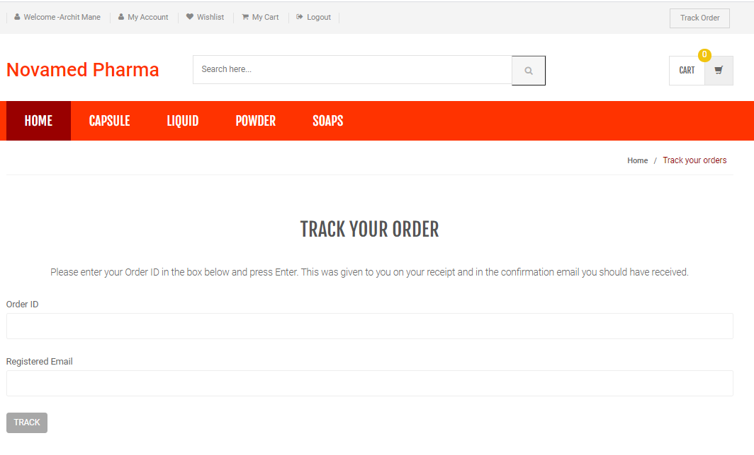

1. User can track their orders using order id.



1. Wholesaler can add new product to the system.



1. Wholesaler can manage all the products.

**15. PLAGIARISM REPORT**

|  |  |
| --- | --- |
| **Report Title:** | Plagiarism report |
| **Report Link:**  (Use this link to send report to anyone) | https://www.check-plagiarism.com/plag-report/28324971f364fc0b6d968858cee0eca  7986f91621786289 |
| **Report Generated Date:** | 23 May, 2021 |
| **Total Words:** | 8637 |
| **Total Characters:** | 35609 |
| **Keywords/Total Words Ratio:** | 0% |
| **Excluded URL:** | No |
| **Unique:** | **88%** |
| **Matched:** | **12%** |

**16. REFERENCES**

[1] Ashwani Chaturvedi, Amrish Kumar. " Online pharmacy : An E -Strategy for medication ", April 2011.

[2] Kwabena Asomanin Anaman. " Assessment of Pharmaceutical Wholesale Market in Ghana: An Incentive Survey ".September 2010

[3] Mishara R , Sathyaseelan B." Generic Drug Distribution in India and Challenges".

[4] Naina Thorat, Dr Ravi Kulkarni. "A review - Role of Mobile Application for Medical Services". March 2019.

[5] Petra Schubert. "Schubert Case Study Triamun Case Study Triamun: Solving IT integration problem in the Health Care Sector with the Innovative Use of an. ASP Software Solution". January 2004.

[6] Anup Nagraj , Swati Tambi." Counterfeit medication: Perception of doctors and medical wholesale distributors in western India". Mar 2015

**WebSites**

[1] <https://www.w3schools.com/>

[2] <https://www.geeksforgeeks.org/>

[3] <https://www.wikipedia.com>

[4] [https://www.stackoverflow.com](https://www.overflow.com)

**Search Engine**

[1] [www.google.com](http://www.google.com)

**ATTACHMENTS**

**SCANNED COPY OF SPONSORSHIP LETTER**

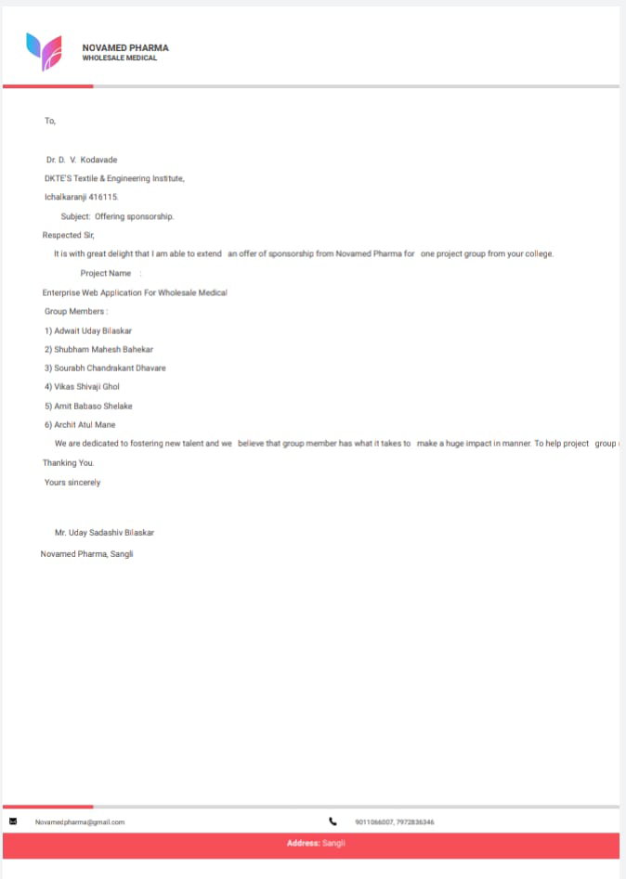

**SCANNED COPY OF COMPLETION LETTER**

